Liberation of the European and Austrian Internal Electricity Market

written by Wolfgang Lackner

Abstract
The Theory says that competitive markets only do well if they are free. In the past, most electricity markets have been regulated by governments. With the Internal Market Directive, the European Union made member countries liberate their electricity markets. To make the European markets more efficient they need to work together and have the same fundamentals. Since the liberation, electricity prices got lower. As a side effect stock markets for electricity have been made to create incentives for companies to produce more efficient. Because of the market directive also the renewable energy market can act on a more competitive basis.

- Introduction

Originally the electricity and gas markets were seen as natural monopolies which are justified in a free market economy. But it is not said that a monopoly can lead a whole economy into a strong and competitive position.
The European Union had to face exactly this problem. To ensure international competitiveness in a global economy energy prices need to be low and the energy markets have to be as efficient as possible. Incentives for a more efficient energy production and distribution have to be created such that the market participants act in the best way possible.
In 1996, after 5 years of negotiations the European commission for energy came to a final decision concerning the “Directive concerning common rules for the internal market in electricity and repealing Directive”. By that an important step towards the liberation of the European electricity marked has been made (EURLEX, 2012).

- Main Points of the Internal Market Directive

The following points describe the internal market directive:
- Unbundling
- Organizing the grid access
- Grid charges
- Horizontal control Areas
- Regulation authority

  - Unbundling

To avoid market failures, caused by cross subsidization and competitive distortion, integrated electricity companies have to separate accounting for production, transmission and distribution. Also parts that have nothing to do with the electricity sector have to be considered separately (EURLEX, 2012).

  - Organizing the Grid Access

As to the content of grid access, member countries can choose one out of two systems.

Third Party Access
The first system called Third Party Access, determines the grid access as regulated and negotiated. Electricity producer, electricity supplier and all customers agree to a contract on a voluntary basis. The conditions of the grid access are determined by individual contracts between grid operators and customers. If the regulated grid access has been chosen, a law or an enactment determines the property rights of the grid usage.
The regulated grid access is the most common used form to open the market.

Single Buyer Model
In case of the Single Buyer Model the member states can declare a juristic person as a so called single buyer in a, by the grid operator covered area. The local grid operator (single buyer) bundles the electricity purchases on his own bill and distributes it then to his own customers. The arrangement, mostly for mid and long term delivery contracts between electricity producers and the local grid operator (single buyer) is done in a competitive organized auctioneering procedure. Until the contract ends, the supplier underlies no competition by other suppliers (EURLEX, 2003).

  - Grid Charges

The operation of grids is not affected by the liberalization because it can be considered that transport and distribution grids are always provided by natural monopolies. In this case it would not make any sense to liberate it because of the very high fix costs. To avoid abuse by the transport and distribution grid operators, special control measures have to be taken.
To ensure a fair distribution of the costs for maintenance and for construction of new grids, grid charges are made by regulation institutions. If changing the electricity supplier, the new supplier has to pay these grid charges to the new supplier and the grid operator. But it can be considered that these additional costs will be passed onto the final consumer (EURLEX, 2003).

  - Horizontal Control Areas

To control the energy flow in a technical way the international transmission network, it has to be divided into control areas. The international transmission network consists of many different parts and each of them is operated independently.
Each control area comprises a part of the transmission network. Wires that pass any boarders of a control area have capacity meter installed. The gathered data is transferred to the controlling center online. The amount of electricity that has to be delivered over the control area’s boarders, recording to the delivery contracts, is calculated a priori. Because of that all power plants can be operated in a most efficient way s.t. the contracts can be fulfilled (EURLEX, 2012).

  - Regulation Authorities

Within the internal market directive only a few points are a hint that a regulation authority has to be installed by each member state. Each member state has to name a proper authority which has the task to smooth over differences in contracts and negotiations concerning onward transmission of electricity and access refusals. These authorities also have the right to examine accountings of production-, transmission- and distribution companies.
Regulation authorities of the member states also have to implement mechanisms for regulation, be in control and provide transparency to avoid abuse of companies with monopoly status within the market. They also have to ensure that none of the bigger companies eliminates the smaller ones that have a weaker market position (EURLEX, 2012).

Another important area of responsibility of the regulation authorities is the bottleneck management. That simply means that if the capacity of a transmission wire on a national basis is not able to transmit all the energy, resulting in the international trade between market participants, the regulation authority has to watch out that this does not even happen (EURLEX, 2012).

- Liberation of the Austrian Electricity Market
After the European electricity market directive has been decided in 1996, Austrian government implemented the plans too in 2001. Since October 1st, 2001 the electricity market in Austria is liberated by 100%.
By implementing the electricity market directive in Austria through the “Elektrizitätswirtschafts-und –organisationsgesetz(ElWOG)“ in 1998, a general framework was set to strengthen the competitiveness of the Austrian economy. This law was designed to open the market step by step, by 35% until 2003. But by an amendment of the ElWOG, the opening of the market by 100% could be realized. The remodeling the law originated out of the dissatisfaction of the final consumers with the step by step opening. Small and middle sized companies argued against it because they feared disadvantages compared to bigger companies. Also the domestic consumers complaint about the law because they thought not only companies should get their benefits out of the liberated market. Austria went far beyond the initial European market guidelines and can be counted to the pioneers of the electricity market liberation in the European Union. (Strommarktliberalisierung in Österreich2002)
By liberating the electricity markets, the sectors of production and distribution have been put on free markets. Since that every consumer has the right to choose which electricity supplier he wants. Hand in hand with the liberation comes a spot market where every market participant can trade electricity like every other good. Because of the very competitive market, benefits in terms of efficient pricing and higher productivity of the market participants, have been gained.
Because of the reason that the grid was still a natural monopoly, not every part of the electricity system was liberated to the free market. Because of the high fixed costs of the grid, it is not economically to run more grids by different companies. To not letting the grid operator gain too much market power a regulation authority was installed, namely the E-Control Commission. This is important because as the grid operator is playing a key role between the energy producers and consumers, he could easily block the market activities of them both.
We can now see that liberation does not simply mean putting away all regulatory instruments and rules. The intention of liberation is more that the market is given the possibility to develop the market mechanisms wherever possible. Especially in this case, where a monopolist remains in the free market should be meticulous rules to set a limit to the market power of the grid operator (E-Control, 2012).

- Electricity Prices
As a result of the liberation of the energy markets in the EU, in some member states stock markets for energy were formed. Because of that it was possible do get a more standardized energy market what was positive for many market activities. Markets became more liquid and market participants could get rid of risk. If a trading partner could not fulfill the contracts, there was no problem anymore to find a replacement. The prices, made on the stock markets are reference prices for the whole European energy market and are very important indicators for the electricity price development. The relevant stock markets for Austria are the EXAA and the European Energy Exchange(EEX) in Leipzig (E-Control,2011).
Figure 1 and 2 show the pricing system, the so called merit-order. The merit order simply determines the order of the used power plants sorted by marginal costs. Briefly, starting with the lowest marginal costs, power plants are activated one after each other until the electricity demand is covered and the market is cleared.
The marginal costs determine the price of the next produced unit, in our case electricity in MWh. On each market companies offer their products at the level of marginal costs in the short run. We can also say that these are the short run variable average costs, where the company can still offer their product. This may not be possible in the long run because the company might get bankrupt but in the short run there may always be another company offering products at the marginal costs. In a case of complete information about the pricing structures of all market participants everyone would offer their product on marginal cost levels. In the case of electricity traded over the EEX this is not the case. Every market participant only knows his own price. After the overall price is made by the stock market the lowest and highest prices are revealed. Because of that each participant on this competitive market has an incentive to offer their product at marginal costs. At least as near to it as possible (Pindyk, Rubinfeld, 2009).
On a functioning free competitive market an average price is formed. Considering electricity is offered to a very low price without any time limit. Then the electricity is demanded by many and the price is rising. More electricity is offered to a higher price and the more is offered at a certain moment the more falls the price. With the available information an average price for a whole day is defined as known for other futures on the stock market.
The merit-order system does not need such an average price. The price is determined by the last power plant needed to cover the demand, sorted by marginal costs. The idea behind it is: At a fully transparent market a rational behavior, every market participant would have known the demand and supply curves. The price of one MWh would be at the marginal costs of the last power plant that is needed to cover the whole supply at the end of the day (EEX, 2012).
This model only works in fully liberated markets. If the markets are not opened by 100% there is the possibility of price manipulations through a faked supply shortage if there are too less suppliers. Because of the high number of decentralized renewable energy suppliers this simply cannot happen anymore in a fully liberated market.

- Merit-Order Effect

In this chapter we will see what happens if a new power plant, a new technology or simply cheaper power generation methods enter the market. The merit order effect describes how the prices change if somebody can supply electricity with lower marginal costs. This effect can also appear during a single day because of wind and solar power plants.
If the sun is shining enough or wind power plants can generate enough energy, the more expensive fossil energy sources gas and oil often get pushed out of the market temporarily. Especially solar power has the most potential during noon because of two reasons. First it’s the time with the highest solar intensity and second it’s the time when peak load is needed. Figure 1 and 2 show the effect for Austria in 2008. In periods when the wind turbines could produce electricity the price lowering was 20€/MWh if 100% of the wind potential was utilized.
By the graphics we can also see how much profit every MWh produced by different technologies can be made. Because the price is determined by the marginal costs of the last power plant that has to be used to cover the demand, sorted from the lowest to the highest marginal costs, cheaper energy gains a much higher profit. That creates incentives to gather more and more energy by renewable sources. The main point why the conventional energy sources are that much expensive are the fossil fuels. Even if fossil fuels are needed to cover the energy demand and compensate the volatility of renewable energies, there is still an incentive to work more efficient and use less fossil fuel.
Another incentive and game changer comes into the market if CO₂ emissions are added to the prices and get internalized into the market. This is very important to avoid market failures and reduce emissions. This also helps do subsidize renewable energy. If we look at figure 2 and imagine that all the rectangles of the fossil energy generation technologies get higher because of the added costs of CO₂ Emissions per MWh, the renewable sector would gain even more profits and get more competitive compared to the fossil sector.

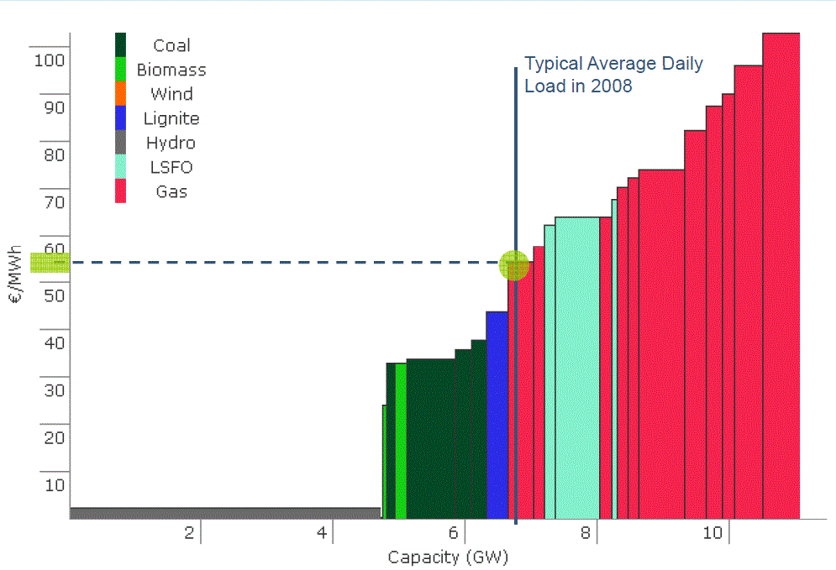
Figure 1: Merit-Order in Austria without wind power plants and the resulting average daily load for 2008(SusPlan, 2009)

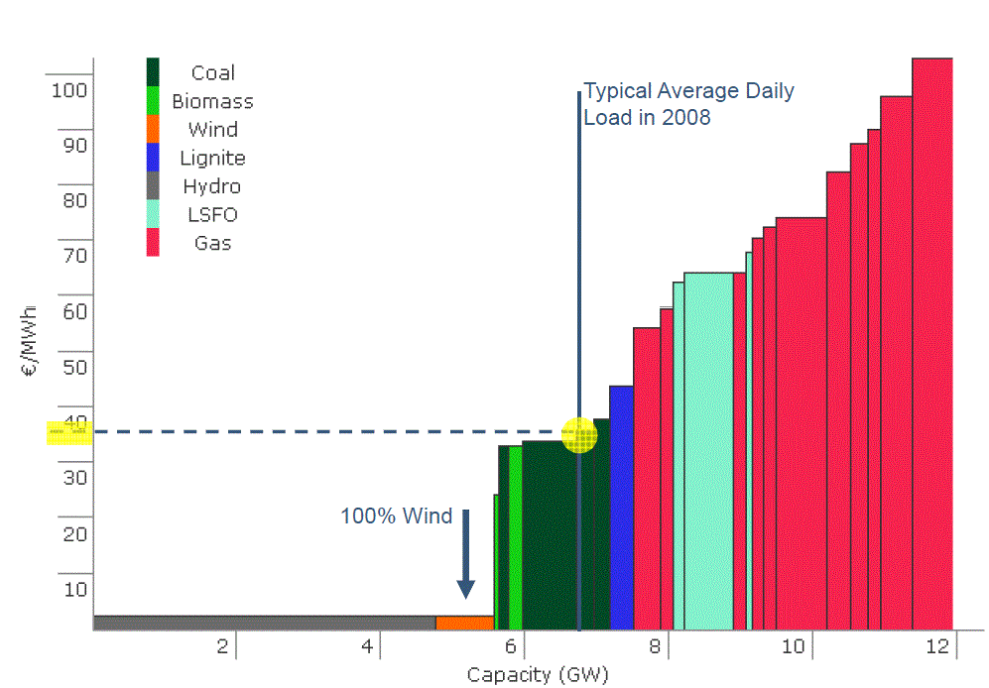
Figure 2: Merit-Order in Austria including generating wind power plants and the resulting average daily load for 2008(SusPlan, 2009)

Conclusion

Because of the liberation of the electricity market in Austria it is more likely that the market is more efficient on a multilateral basis. It became easier to trade electricity via long distances, for more efficient prices and with lower risks. The Internal Market Directive represents the common law for electricity generation, transmission and distribution in the EU. Besides the liberation also stock markets for electricity have been created to invent a very efficient pricing system, the Merit-Order-System. Because of that system, companies have high incentives to produce on the lowest costs as possible. The system made the market for electricity from renewable sources even more competitive. Because of adding the CO₂ emission to the price

E-Control, 2012, „ Gesamte Rechtsvorschrift für Elektrizitätswirtschafts- und –organisationsgesetz 2010 , Fassung vom 04.01.2012 “,http://www.e-control.at/portal/page/portal/medienbibliothek/recht/dokumente/pdfs/ElWOG-2010-Fassung-vom-04-01-2012.pdf, 6.6.2012
E-Control, 2011, “Zehn Jahre Energiemarkt-Liberalisierung in Österreich”, http://www.e-control.at/portal/page/portal/medienbibliothek/presse/dokumente/pdfs/bericht-10-jahre-energiemarktliberalisierung.pdf, 6.6.2012
EurLex, 1996, “Richtlinie 96/92/EG des Europäischen Parlaments und des Rates vom 19. Dezember 1996 betreffend gemeinsame Vorschriften für den Elektrizitätsbinnenmarkt”, http://eur-lex.europa.eu/LexUriServ/LexUriServ.do?uri=CELEX:31996L0092:DE:HTML, 6.6.2012
EurLex, 2003, “Directive 2003/54/EC of the European Parliament and of the Council of 26 June 2003 concerning common rules for the internal market in electricity and repealing Directive 96/92/EC - Statements made with regard to decommissioning and waste management activities”, http://eurlex.europa.eu/LexUriServ/LexUriServ.do?uri=CELEX:32003L0054:EN:NOT, 6.6.2012
European Energy Exchange, 2012, www.eex.com , 6.6.2012
Pindyck R., Rubinfeld D., 2005 Edt. 7, “Mikroökonomie, Pearson
SusPlan, 2009 “Optimisation of Hydro Power Plants Concerning Renewable Energies”, www.susplan.eu, 6.6 2012

